What the
IRISH ROOM
means to me

James W. Knox
CHAIRMAN
IRISH ROOM COMMITTEE

University of Pittsburgh
Pittsburgh, Pennsylvania
1992

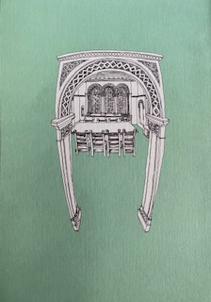

When the Irish Classroom in the Cathedral of Learning at the University of Pittsburgh was completed in 1957, we hoped that the chairman of the Dublin Committee, Dr. Felix Hackett, professor of physics and electrical engineering at Dublin’s National University would be present for the dedication. Unfortunately, this was not possible as his wife Mary became ill. Dr. Hackett made a tape for our dedication ceremonies entitled, “What the Irish Room means to us in Ireland.” He had served many years as the Irish Room chairman along with Dr. Harold G. Leask, chief inspector of the National Monuments of Ireland; Dr. Constantin P. Curran, member of the Royal Society of Antiquaries; Monsignor Padraig de Brun, president of Galway University; and Rev. John Ryan, professor at the National University of Dublin.

Having recently listened again to this tape, I was inclined to put some thoughts in writing, some thoughts on what the Irish Room means to me and to share these thoughts with the members and friends who make up the Irish Room Committee.

It was during my junior year as an undergraduate at the University in 1941, when seated in a corner of the Commons Room reading, a lady approached me, introduced herself as Mrs. Mitchell and invited me to tea, which was set in the room and about to be served. There began, with this brief encounter, my association, until her death in 1984, with one of the most remarkable persons I had ever met – Ruth Crawford Mitchell – the founder of the Nationality Rooms program and its director until 1956. She served as Director Emeritus from 1957 – 1984.
In a letter to me from Dr. Hackett, dated November 17, 1964, he tells of a visit to Dublin by then vice chancellor and Mrs. Albert C. Van Dusen and a renewal of his ties to the University of Pittsburgh and the Irish Room. He states the following in his letter: “For the pleasant company around the dinner table in the Shelbourne Hotel, I sketched briefly how my association with the Irish Room began, way back so many years ago in the chance meeting with Mrs. Ruth Crawford Mitchell in the post-van from Killybegs to Carrich on our way to climb Shive League and all its fine cliffs facing the Atlantic to South Donegal.” And so “the beginning.” Killybegs is the ancestral home of the late Mayor and Governor David L. Lawrence, a charter member of the Irish Room Committee.
The Irish Room as well as all the Nationality Room Classrooms are memorials to our ancestors – immigrants who left their native lands to make a new home and build a Nation here in Pittsburgh. My parents, Mary Reid and James Robert Knox, were a part of this immigrant group. It was the vision of Chancellor John Gabbert Bowman who proposed the idea of the Nationality Classrooms and invited Mrs. Mitchell to direct the program. These were the words Chancellor Bowman spoke at a meeting in Duquesne describing the reasons for designing the dramatic Gothic renewal tower, now known as the Cathedral of Learning, and the construction of the elegant Nationality Classrooms.

“The Building was to be more than a school house; it was to be a symbol of the life that Pittsburgh through the years had wanted to live. It was to make something of the spirit that was in the hearts of pioneers as long ago they sat in their log cabins and thought by candle light of the great city that would sometime spread out beyond their three rivers and that even they were starting to build.”

The Irish Room as well as all the other Nationality Classrooms are memorials to our ancestors….

“A day or two later, Mrs. Ruth Crawford Mitchell, a lecturer in sociology at the University, came into my office. I told her about the meeting at Duquesne. Yes, she knew these steel folk, she said, and how they had lived in their homeland, and how they were living now. She knew that many of them wanted to go back to their Old Country and that the women specially were homesick for their folk songs and native costumes and church bells.”

“There was a feeling of elation, of quiet joy, among these groups as they went about work which almost defies description. Their happiness was more than a mood. Year after year it lasted, partly, it was response to the enthusiasm and to the sincerity of Mrs. Mitchell.”

My personal participation in the Nationality Rooms program has been an important part of my life, not only to be a part of the Irish Room Committee, but to come to know those who make up all of the Nationality Room committees. It has provided me with the opportunity of knowing about and meeting those who worked so hard over the year to create our charming Irish Room.
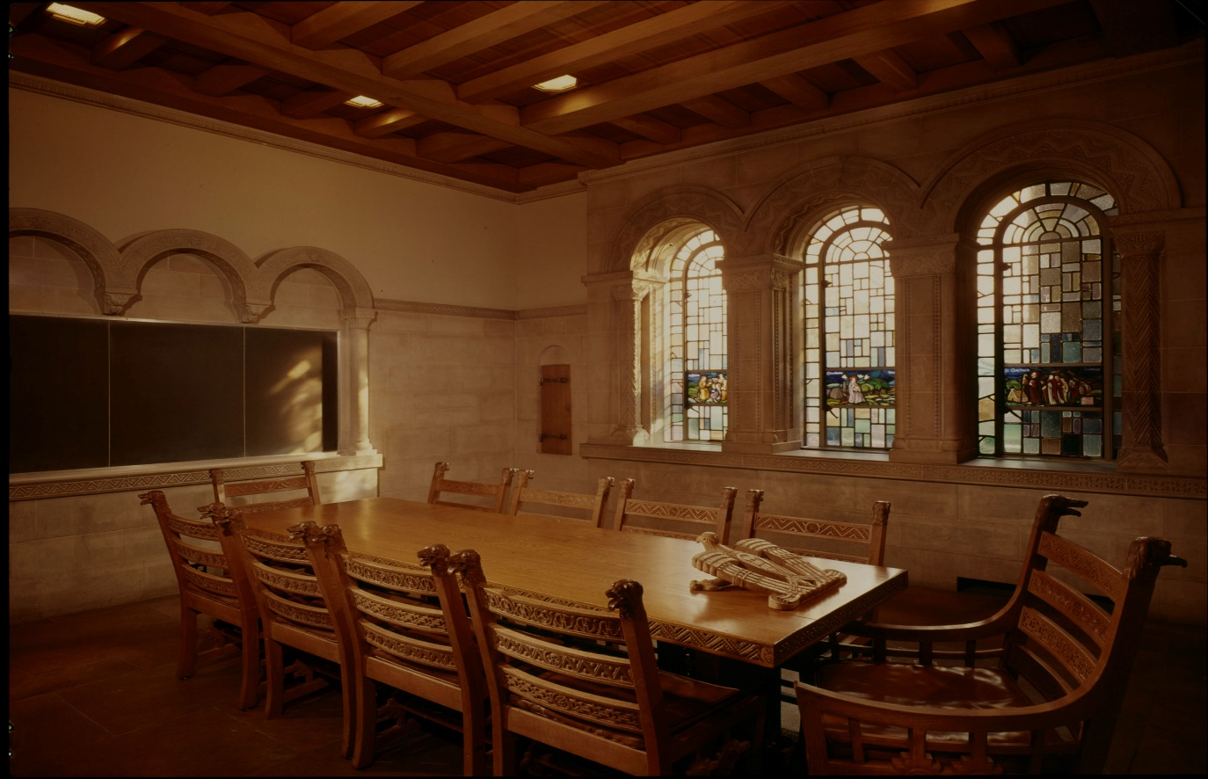

Veils of carvings cover the Irish Room pillars and arches punctuated by pre-Christian human and animal masks.
Daily throughout the school year in the city of Pittsburgh more than 100 university students meet for classes in a replica of a sixth-century stone oratory from the west coast of Ireland.

The Room is one of the 23 Nationality Classrooms at the University of Pittsburgh. The classrooms, each designed in a different national style, were built to honor the people from many countries who settled in the state of Pennsylvania in the Pittsburgh region.

For students from other countries who study at the University each year, the Classrooms also serve as vital symbols of an expanding educational exchange program. The University welcomes secondary school graduates and mature students of all nations. It also offers a number of teaching fellowships to international graduate students.

Located in the city’s cultural center, the University of Pittsburgh is a coeducational institution with a current enrollment of 34,400 students. Its 17 schools and divisions grant both baccalaureate and graduate degrees.

The central building of the University is a 54 year-old, 42-story, Neo-Gothic “Cathedral of Learning,” built as a symbol of that institution’s high goals and ideals. It is in this building, around the Commons Room, that the Classrooms are located.

When the Cathedral of Learning was being erected, the city’s various nationality groups decided that they wanted in some way to contribute to it. The Nationality Classrooms, unique expressions of the heritage of the various groups, were decided upon as the proper instrument, and a committee from each nationality formed to create a room. The principal requirements were that the design had to be authentic, represent a period prior to the founding of the United States and the University in 1787, contain no political symbols, or depict any living person.

An Irish Classroom Committee was formed in 1936. It was assisted in its work by the Dublin Advisory Committee.

When the Cathedral of Learning was being erected, the city’s various nationality groups decided that they wanted in some way to contribute to it.
The design selected for the Classroom is the Gaelic Romanesque style, which flourished from the sixth to the twelfth centuries, often called the Golden Age of Irish history. The Room is the exact dimensions and materials of an oratory of that period.

Dr. Harold G. Leask, Dublin architect and outstanding authority o Irish Romanesque architecture, prepared scaled drawings for the Classroom’s ornamental stone carvings. The drawings were sent as a gift from the Irish Republic’s Department of External Affairs to the University of Pittsburgh. Of the style Leask observed: “The decoration is in low relief and covers – like a veil – the surfaces of pillar and arch.” Dr. Albert A. Klimcheck was the University architect in charge of construction of the Irish Room.

The Room’s symbol is a Celtic cross which appears in stone above the archive cabinet and on the cabinet key. The cabinet houses archives bound in hand-tooled leather and illuminated by master book binder Thomas Patterson. Other well-known emblems are the shamrock and the harp, which are carved in the stone outside the Classroom above the door. The Room’s great oak table, chairs, and benches are ornately carved from illuminated designs in the Book of Kells. A copy of the Book of Kells and a copy of the Book of Durrow were gifts from the Mellon family and the Irish government, to the University’s library. A beautiful wrought-iron stand exhibits scriptures from the Book of Kells. This stand, designed by Theodore Bowman, was crafted by Samuel Yellin Metalworkers and commissioned by Miss Helen Clay Frick.

The entrance with deep inclining jambs, was adapted from the entrance of Killeshin Chapel in County Leix. The triangular gable, however, is within the Room rather than outside the entrance as in the original. At the gable’s apex is a cat mask and near the top of the pillars is a frieze-like band of human masks.

Opposite the doorway, designs in the arches and pillars of the window wall are adaptations from the Church of Clonkeen near Limerick. The three large windows contain brilliant stained glass medallions, gifts of the Irish Republic.

The Room’s great oak table, chairs, and benches are ornately carved from illuminated designs in the Book of Kells.”

Themes for the medallions were suggested by the Rev. John Ryan, professor of early Irish history of the National University of Ireland at University College, Dublin. They depict the three major Christian schools of Ireland with their most famous teachers – Clonard with St. Finian, Derry with St. Columkille, and Lismore with St. Carthage. Sunlight streaming through the medallions casts rich red, green, and blue reflections in the Room. The designing and fabricating was done in the Harry Clarke Studio, Dublin.

A glass blackboard, in the front wall, is recessed in an ornamental stone frame decorated with segmental arches. Each arch is capped with a wild dog or wolfhound and in its center a keystone with a stylized cat mask.

The Room’s cornerstone, also in the wall, is an original block from the Abbey of Clonmacnoise near Athloe. Behind it is a sealed metal container holding Irish Room Committee records and earth from Navan Fort, County Armagh, and the Hill or Tara, County Meath. The Gaelic inscription reads, “For the Glory of God and the Hoor of Ireland.”

At the base of the arch in the back wall is a richly sculptured stone bench, inspired by the coffer of King Bishop Cormac in his chapel on the Rock of Cashel. Its motif is a greyhound-like animal wreathed in interlacing vines.

The heavy oak ceiling of the Classroom is characteristic of the oratory ceilings which kept the ancient rooms warm in winter by shutting off space under their sloped roofs.

Each arch is capped with a wild dog or wolfhound and in its center a keystone with a
stylized cat mask.
Settlers from Ulster, including the Scotch-Irish, made substantial contributions to Pittsburgh’s growth and development. Calvinists and Presbyterians seeking freedom for their beliefs, began immigrating to the United States in the early 1700s and established a settlement near Philadelphia. As more arrived, many settlers moved westward to the then small town of Pittsburgh, on the fork of the Allegheny, Monongahela, and Ohio Rivers. So completely did they permeate all aspects of the city’s civic and industrial growth that an early population census gives no separate figure for their numbers.

The Scotch-Irish were particularly influential in establishing the city’s educational institutions. A majority of the early trustees of the Pittsburgh Academy, which later became the University of Pittsburgh, were of Scotch-Irish origin. Three theological seminaries founded in the early 1800s also testify to their interest in education.
Since the completion of the Classrooms, the Nationality Committees have continued to bring into the University an infusion of the cultural values of the countries they represent.

The Irish Committee supports a scholarship fund enabling a Pitt student to study in Ireland each summer. The Committee invites lecturers to speak on Irish economic and cultural affairs. It extends hospitality to visitors from Ireland, shares in the orientation of University students and faculty before they go overseas, and plans programs that assist Americans returning from Ireland to interpret the insights they have gained. The Committee also helps the library acquire Irish books.
It was Mrs. Mitchell's Intent that this Irish classroom and its committee represent all of the island known as Ireland. She requested a five-member committee. The first president was Samuel B. Casey followed by Judge Walton Mitchell of the Orphans Court. When the room was dedicated on Saturday afternoon, May 18, 1957, the address was delivered by His Excellency John Joseph Hearne, Ambassador of Ireland to the United States. James J. Hayden was chairman of the Irish Room Committee. The presentation of the Irish classroom to the University of Pittsburgh was made by the Honorable David L. Lawrence, then the Mayor of the City of Pittsburgh and member of the Irish Room Committee. The Room was accepted by Dr. Edward H. Lichfield, Chancellor, and has been in use since by day and evening classes. A gala luncheon was held on Sunday, May 19th, 1957 at the home of Mrs. Horace Forbes Baker in Sewickley with Ambassador Hearne as the honored guest.
It was Mrs. Mitchell’s intent that this Irish Classroom and its Committee represent all of the island known as Ireland.”

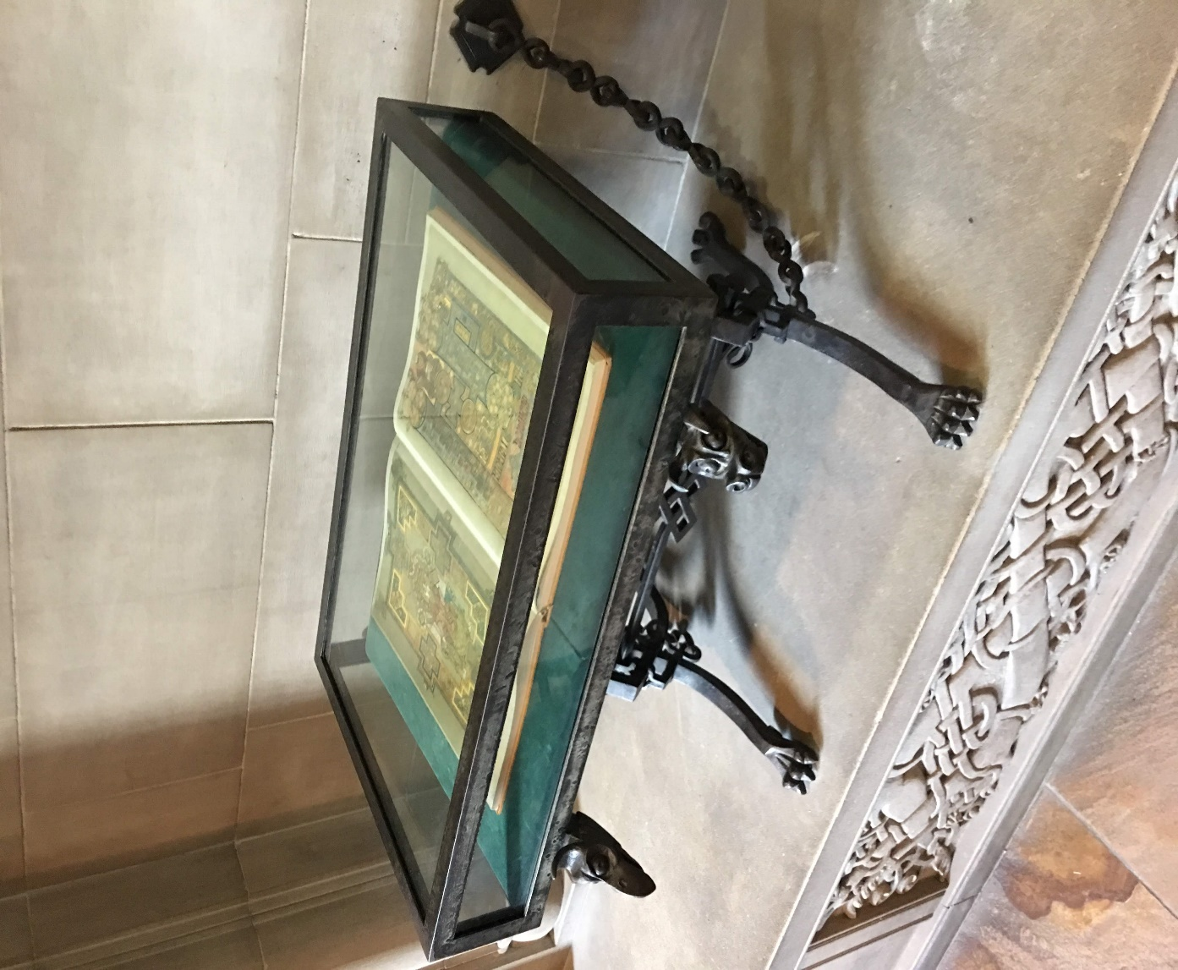

The sculptures from the 8th-century Book of Kells rest in a wrought-iron case on
animal and bird supports inspired by ancient illuminations.

COMMITTEE FOR THE
IRISH CLASSROOM IN PITTSBURGH

OFFICERS
Mr. James J. Hayden, chairman
Miss Adelaide Mitchell, vice chairman
Mrs. Peter T. Dana, secretary
Mr. James W. Knox, treasurer
MEMBERS
Mrs. Horace Forbes Baker
Mrs. Catherine Byrnes
Mr. Walter J. Curley
Mr. Francis Feehan
Mr. E. Bruce Hill
Mr. David DeLong Jones, III
Miss Mario Keating
Mayor David L. Lawrence
Mr. Francis J. McGuiness
Miss Marie McSwigan
Dr. E.P. Moriarty
Mr. Martin J. Mullen
Miss Mary Roberts
GENERAL COMMITTEE MEMBERS
Mr. Edward Buch
Mrs. Catherine Dougherty
Mrs. Mary Doyle
Mrs. Margaret Fogarty
Mr. J. Francis Halpin
Mr. John H. Harris
Mr. John J. Kane
Mr. John M. Kane
Mr. Edward J. Kelley
Mr. Leo J. Kelly
Dr James J. Lee
Miss Ethel M. Leonard
Mr. Thomas J. McCaffrey, Jr.
Mr. Brady McSwigan
Mr. James P. Murray
Mr. James C. Rea
Mr. Simon J. Robertson
Mr. Arthur J. Rooney
Dr. Hugh P. Ryan
Mr. John T. Ryan, Jr.
Dr. J. Staunton Sailing
Mrs. Leonard P. Shea

PRESENT OFFICERS OF THE
IRISH ROOM COMMITTEE:
James W. Knox, chairman
William R. O’Malley vice chairman
Margaret Wynne, secretary
Earl A. McCabe, Jr., treasurer

The names of the Committee which appeared on the programs are listed on this page.
What a privilege it has been for the past 50 years to have the opportunity of learning about the roots of my Irish ancestors and of their contribution to this community. How enriching the experience has been to meet so many wonderful people from here and abroad who share the Irish heritage. Perhaps the greatest joy of all is to work with the present Committee in raising funds each year for the scholarship award for a student to study in Ireland. I am sure that Chancellor Bowman and Mrs. Mitchell would be mighty pleased with the way the Nationality Rooms program continues to thrive under the excellent leadership of the present director, E. Maxine Bruhns, and the various Committees.

For generations to come, young people studying at the University of Pittsburgh will benefit by the creation of scholarship awards. In a world increasingly dependent upon international and intercultural understanding, it is imperative that as many of our students as possible study and travel abroad. This experience encompasses and affects other students, who, of necessity, must think in terms broader than national borders.

I have tried to share with you what the Irish Room has meant to me. I appreciate the support, interest, and concern of so many people who have, by their financial support, made possible our work for “the Glory of God and the Honor of Ireland.”

JAMES W. KNOX
Chairman
May 1, 1992

On this page and the following page are remarks taped for the Irish Classroom Dedication

Cathedral of Learning
University of Pittsburgh
May 18, 1957

~~~~~
Dear Friends of the Irish Room,

I’ve been asked to speak to you on what the Irish Room in the Cathedral of Learning means to us in Ireland and, particularly, to the members of the Dublin Committee for the Irish Room. It symbolizes the great education and influence which spread far and wide from Irish monastic schools during the sixth, seventh, eighth, and ninth centuries. Their fame during these centuries attracted students from foreign lands. More important was the influence of the numerous bands of Irish missionaries who established monastic schools all over western Europe. Their schools were not only centers of religious learning but they also preserved for us the literary treasures of antiquity.

The manuscripts of the Greek and Latin classics collected at Bobaeal in Italy founded by St. Colin Barnas are now scattered or lost but many of them survived to be carefully preserved I the great libraries of Europe. In Switzerland the Monastery of St. Gaul, a disciple of St. Colin Barnas, has a library renowned even in the middle ages. This great missionary spirit expanding from Ireland in the early medieval period has been described by Daneo Rought of the French Academy as the Irish miracle. The well-known German scholar Asemia described the Irish missionaries as instructors in every branch of science and learning of the times; possessors and bearers of a higher culture which was not at that time to be found anywhere on the continent of Europe. And, he concluded, they can surely claim to have been the pioneers – indeed to have laid the cornerstone of western culture on the continent.

The architecture art of the Irish Room derives its inspiration from the Irish art of the centuries of the early Christian period. The last magnificent development by Celtic artists, the inventors of one of the most fastidious and subtle systems of decoration the world has ever seen. We had, in Dublin, the good fortune of having as a member of our committee Dr. Harold Leask, then Inspector of National Monuments, to design the carvings for the Irish Room after the manner of Irish Romanesque to which he had given a lifetime of study. He had reproduced, for example, in exquisite drawings the delicate details of the eleventh century doorway at Killeshin Chapel, County Leix, which served as a prototype for the doorway of the Room. These three panels of stained glass depict symbol-wise the last three monastic schools and their founders. We see St. Finian of the Finn School, which he founded at Clonard by the banks of the river Boyne, noted as the Salmo River, instructing the sainted youths.
St. Columba, on the middle panel, is amongst his beloved Oak Woods at Derry by the River Foyle grasping a book with one hand, holding a quill pen in the other, and so reminding us of the story of his copying of the translation of the Psalms. He appears in the panel under the simple title of Columkille, by which he is known today all over County Donegal. Particularly at Glen Columkille, where his feast day the 9th of June is still commemorated by a traditional pilgrimage.

St. Carthage on the third panel, is pictured on his way to found, by the river Black Water, the great monastery of Lismore, which lasted from 635 to 833 when it was destroyed by the Danes. He carries a crozier having the craftmanship of Lismore. The open pages of an illuminated manuscript shown on this panel recalls one of the great glories of Christian art in Ireland. You have indeed in this Irish Room, as Chancellor Bowman wishes, “walls that teach,” walls that can give the inquiring mind of youth the quintessence of their religious art and learning of those ages in Ireland, when, as Samuel Johnson wrote, “Ireland was the school of the west, the quiet habitation of sanity of literature.”

FELIX HACKET, MA , MS, PhD.
Chairman, Dublin Irish Room Committee
Professor of Physics & Electrical Engineering
National University – Dublin

President of the Royal Dublin Society
President of the National Trust for Ireland
Member – Royal Irish Academy
Chairman, National Library

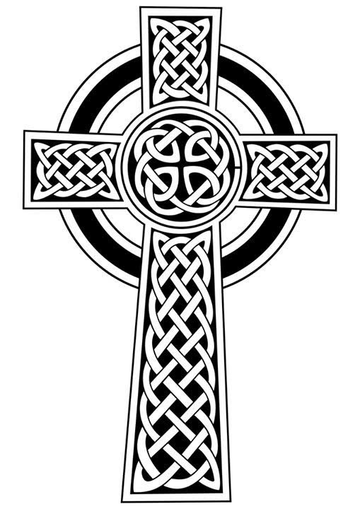

University of Pittsburgh
The University of Pittsburgh is an affirmative action, equal opportunity institution. Published in cooperation with the Department of University Relations
PR9255-992

